110 Stories: 23, 28, 47
COLLAPSE

Post here your comments on "Grammar Questions," "Man on the PATH," and "The Price of Light and Air."
As we begin our discussions, remember to avoid questions of whether or not a story is "true" or "actually happened." As we discussed, Some are based on actual events, some are completely fiction, some are faction--but ALL ARE "TRUE."
"Grammar questions" makes me wonder if, when the big picture is too frightening, we instead focus on arguably trivial things. Not that I consider grammar trivial...
Whenever I read "Man on the PATH," I am immediately pulled out of the story, because the narrator begins, "Early on the evening after the twin towers fell, I took the PATH to Manhattan..." Well, NO, the PATH had not yet resumed service to Manhattan one day later. Fact check, people! But I also think about flags. Americans in particular have made the flag a bit of a fetish, compared to other cultures (except for Nazi Germany, which was also a culture that focused on its flag).

Ex Student work:
"The Grief Technician" was very interesting. I found it morally wrong to manipulate someone's emotions and lie to them by justifying that it's for their own sake. I disagree with the method being used but do understand why it was happening. It is easier for someone to move on from something when they feel betrayed than abandoned, altering the situation by worsening it or showing it's not worth grieving over. It was uncomfortable for me to read for the same reasons mentioned previously, I do think it was successful to tell the story from the technician's point of view rather than the victims since we don't have that attachment to the character that provokes more negative emotions about what was going on.

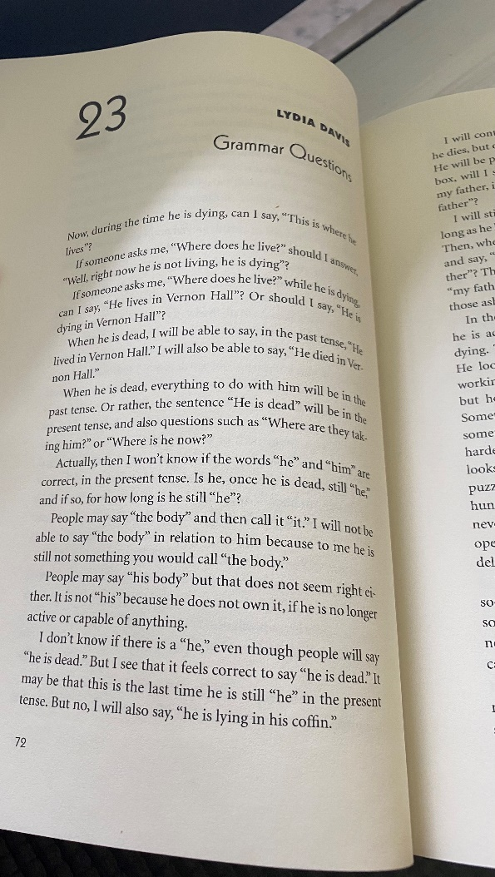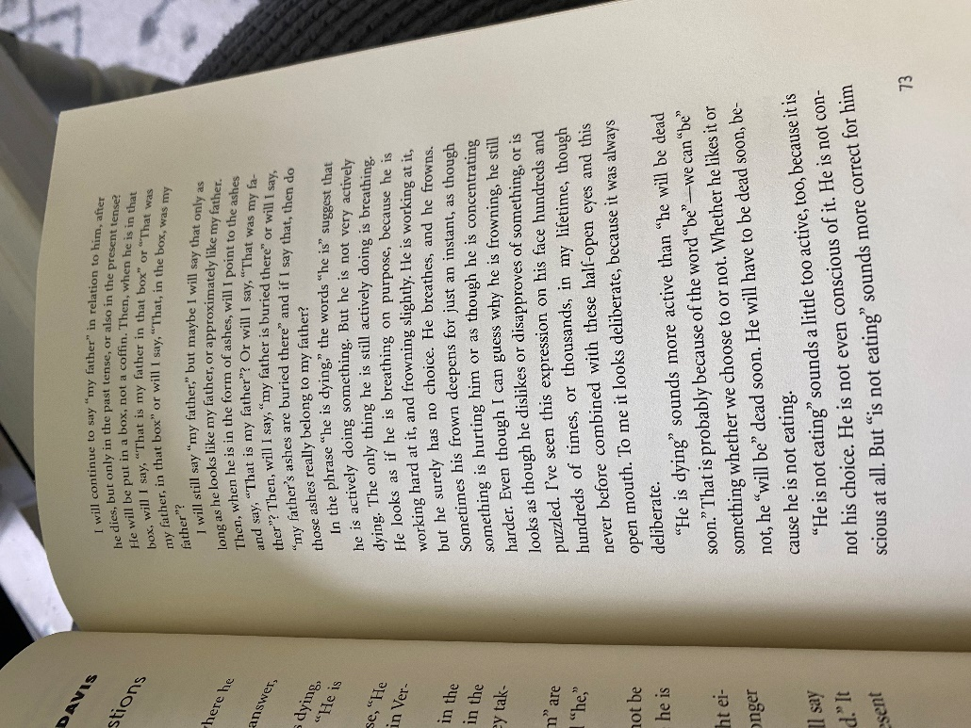

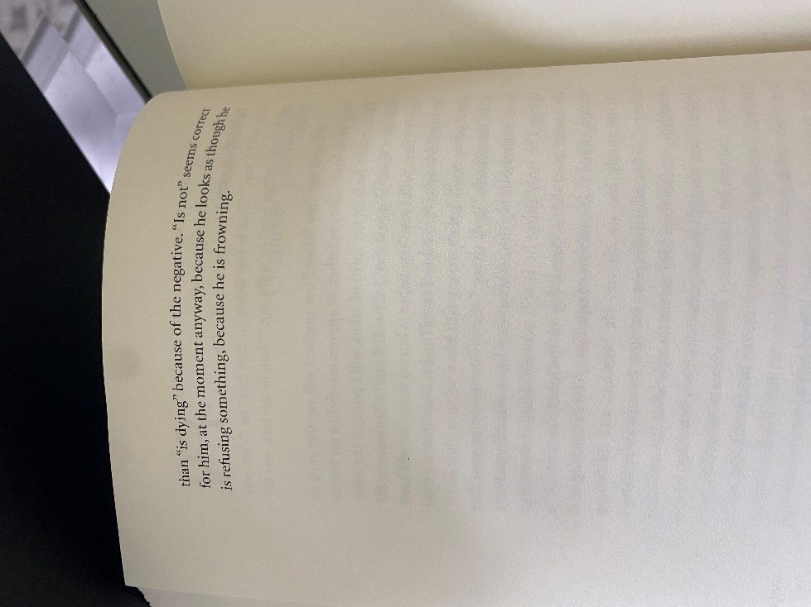
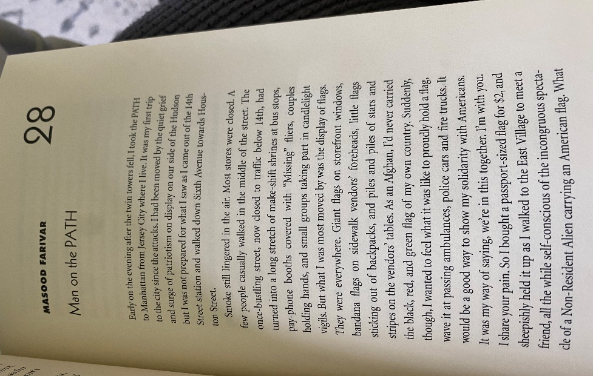
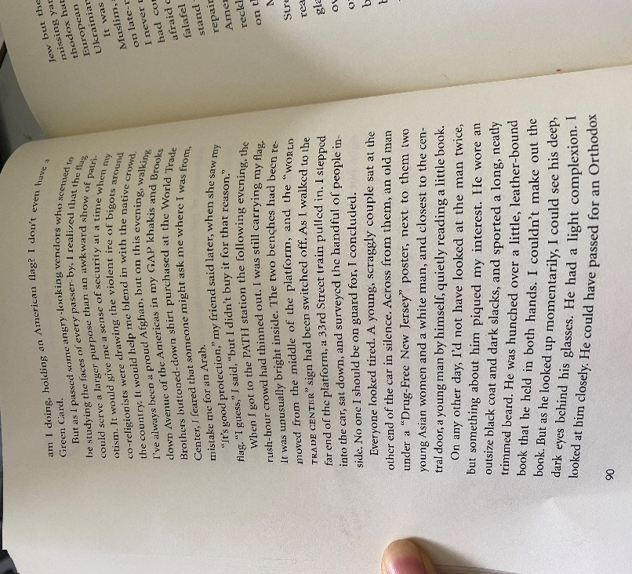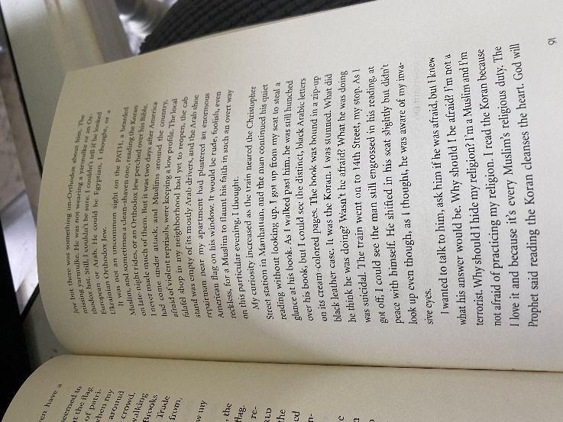

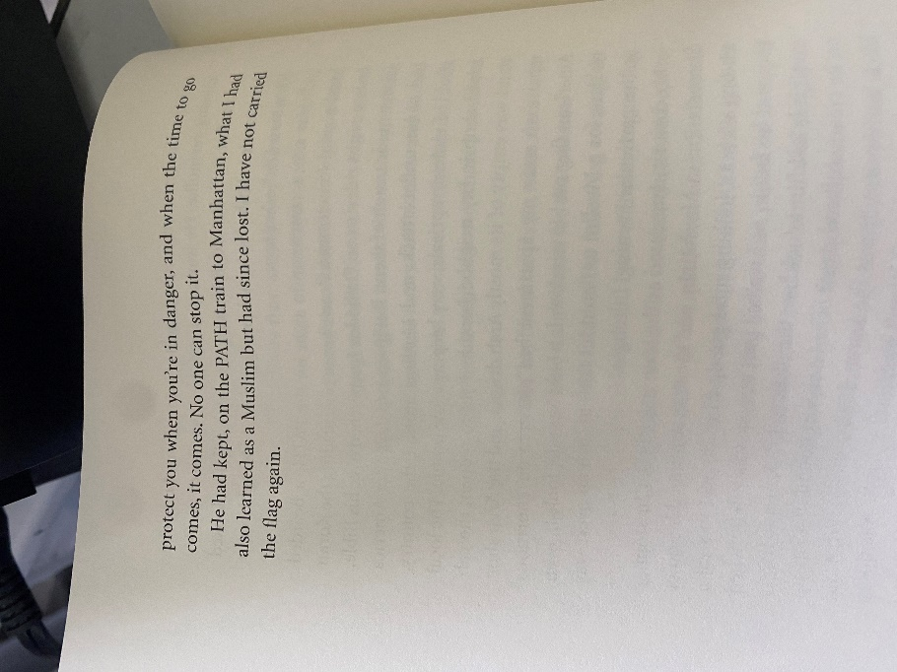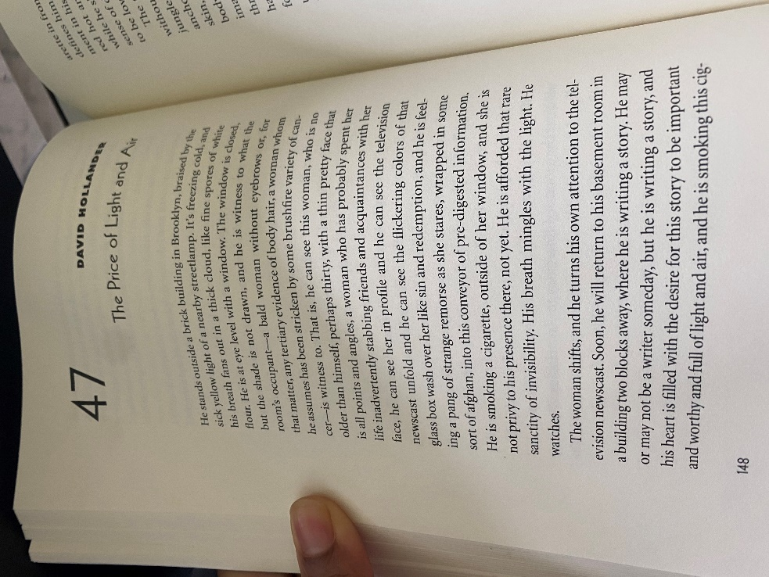
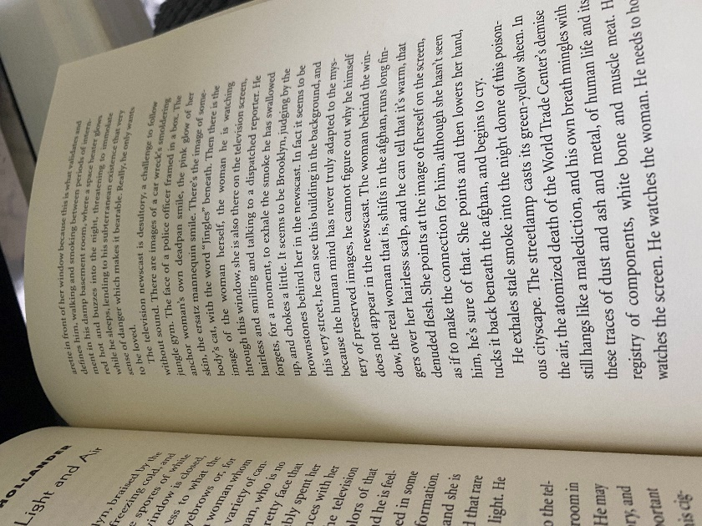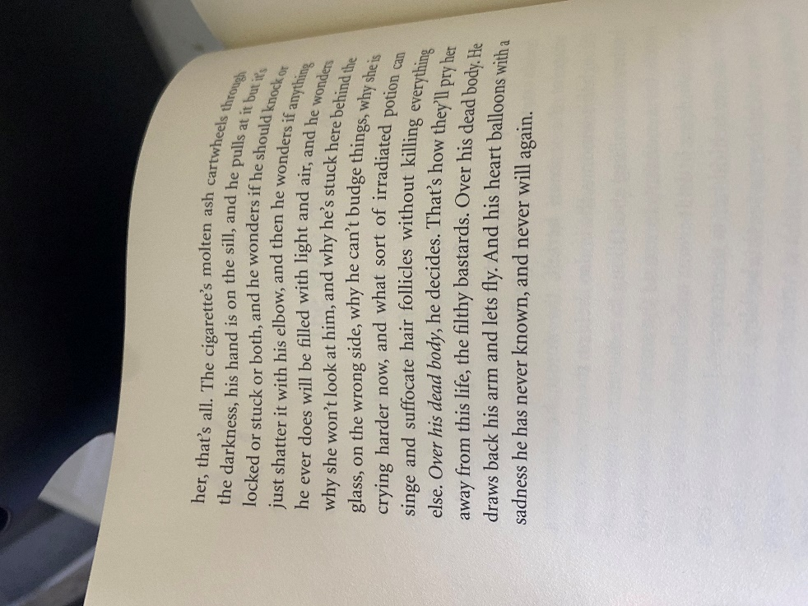
110 Stories: 60, 103, 105
COLLAPSE

Post here your comments on "The Grief Technician," "The Persistence of Who We Were," and "A Terror for Terror."
As we begin our discussions, remember to avoid questions of whether or not a story is "true" or "actually happened." As we discussed, Some are based on actual events, some are completely fiction, some are faction--but ALL ARE "TRUE."
"The Grief Technician" also evokes mixed responses from readers. This story makes me ponder why we resist grieving.
That is some parenthetical comment at the end of "A Terror for Terror," no? I wrote "cheating!" in my margins, since the author admits (claims?) it was written prior to 9/11 so it does not fit the subtitle of the collection: New York Writes After September 11.

